Case Study: ER – Diagram

Online banking allows a user to conduct financial transactions via the Internet. Online banking is also known as Internet banking or web banking. It offers customers almost every service traditionally available through a local branch including deposits, transfers.

With online banking, consumers aren't required to visit a bank branch to complete most of their basic banking transactions. They can do all of this at their own convenience, wherever they want—at home, at work, or on the go.

All the details pertaining to banking application are stored in the form of relations.

Few of the relations mentioned below,

* branch: details of the branches being there under the single bank.
* customer: details of the customers those who creates an account.
* account: details of the accounts owned by the customers.
* trandetails: details of the transactions done by customers.
* payee: Details of all the payees those who receives amount from account holder.

**Problem Statement 1: Enlist all the Entities and Attributes**

BRANCH: BID(primary key),BNAME,BCITYCUSTOMER: CUSTID(PK),FNAME,LTNAME,CITY,MOBILENO,DOBACCOUNT: ACNUMBER(PK),CUSTID(FK),BID,BALANCE,ACCOUNT TYPE TRANDETAILS: TNUMBER(PK),ACNUMBER(FK),DOT,TRANSACTION_TYPE,TANSACTION_AMOUNT PAYEE: PAYEEID(PK), BANKNAME,ACNUMBER,PAYEENAME,USERNAME

**Problem Statement 2: Identify the candidate key, primary key and foreign keys for the above relation.**

BRANCH: BID(primary key) CUSTOMER: CUSTID(PK) ACCOUNT: ACNUMBER(PK), CUSTID(FK) TRANDETAILS: TNUMBER(PK),ACNUMBER(FK) PAYEE:PAYEEID(PK)

**Problem Statement 3: Draw the ER model for the above relation**

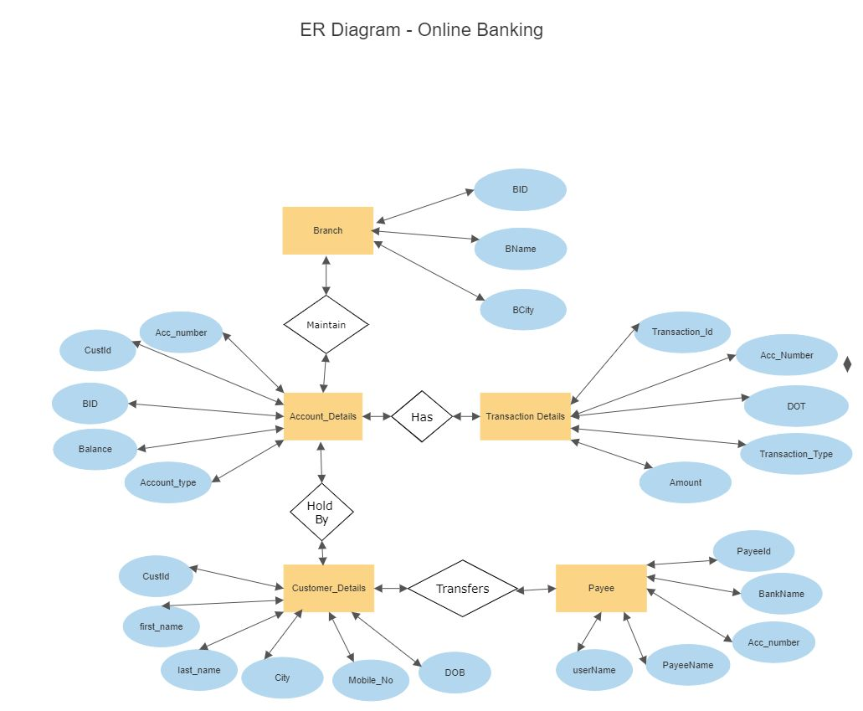

**Problem Statement 4: Identify the Degree of Relationships and Cardinality of all identified relationships**

Customer can have one or more accounts. [customer(1) -> accounts(n)] Customer can add one or more payees. [customer(1) -> payee(n)] Many transactions can done by one account holder. [Transactions(n) -> account(1)]